**Supported Queries:**

* Add/ Remove/ Update records for volunteers and donors.
* Add/ Remove/ Update records for drives and needy_circles.
* Finding the number of volunteers in Kothrud area.
* Finding the number of donors in Deccan area.
* Find the total food distributed by donor by donor_id=09.
* Find the attendance of volunteer by “Abhishek”.
* Find total points of volunteer “Akash”.
* Display total number of drives conducted in circle MIT.
* List the donors in katraj.
* and so on

**Design of the schema:**

In this section, the major entities will be identified along with the possible attributes. Further the relationships within these entities will be modeled.

**Entities and Relationships:**

Entity: member.

Whenever a new volunteer is joined, a unique member_id is generated after storing the name, address, dob ect of member.

Attributes:

* member_id
* fname
* mname
* lname
* gender
* joindate
* dob
* email
* state
* city
* country
* points
* phone
* alternat_phone

**Key(member_id).**

Entity: donor.

Whenever a new donor is joined, a unique donor_id is generated after storing the name, address, dob ect of donor.

Attributes:

* donor_id
* donor_name
* email
* address_line
* city
* state
* country
* type
* phone
* alternate_phone
* points
* area_id

**Key(donor_id).**

Entity: area.

The area has unique area_name, area_id, city, state, country, creation_date, monitor_id.

Attributes:

* area_id
* area_name
* city
* state
* country
* creation_date

**Key(area_id).**

Entity: drive.

Whenever monitor creates new drive a unique drive_id is generated after inserting start_time, max_volunteers, vol_select_method. Status of drive is initiated by default at the time of creation. area_id aslo be there a monitor is going to create the drive.

Attributes:

* drive_id
* status
* max_volunteers
* start_time
* area_id
* monitor_id
* vol_select_method
* end_time

**Key(drive_id).**

Entity: needy_circle.

There are several needy circles in area. needy circle is characterized by circle_id, no_of_peoples, address_line, landmark, area_id.

Attributes:

* circle_id
* no_of_peoples
* address_line
* landmark
* area_id

**Key(circle_id).**

Entity: volunteer.

The volunteer is specialized from member. volunteer has type attribute which make it specialized.

Entity: monitor.

The monitor is specialized from member. Out of number of members one member become monitor of area. monitor has assigned date and experience as monitor attributes.

Relationship: attendance.

Whenever volunteer attends the drive his/her attendance is recorded. The member_id and drive_id is stored. Attended date and time is also stored.

Involved entities:

* member
* monitor
* drive

Attributes from entities:

* member_id
* drive_id
* attendace_flag
* monitor_id

Attributes from relationship:

* date
* time

**Key(member_id,drive_id).**

Relationship: collects_food_from.

In case of drive, when drive is initiated volunteers has to collect food from donors to distribute it to needy peoples. All food collection information is recorded with food_quantity, collection_time, drive_id, donor_id.

Involved entities:

* donor
* drive

Attributes from entities:

* drive_id
* donor_id

Attributes from relationship:

* food_quantity
* date
* time

Relationship: distribute_to.

In case of drive, when drive is in running state the food is distributed to needy peoples. Information about this is stored with drive_id, circle_id, food_quantity, date, time.

Involved entities:

* needy_circle
* drive

Attributes from entities:

* drive_id
* circle_id

Attributes from relationship:

* food_quantity
* date
* time

**Schema:**

* **member(**member_id, fname, mname, lname, dob, joindate, dob, email, phone, alternate_phone, points**)**
* **attendance(**member_id, drive_id, date, time, monitor_id**).**
* **drive(**drive_id, status, max_volunteers, start_time, area_id, monitor_id, vol_select_method, end_time**).**
* **collects_food_from(**drive_id, donor_id, food_quantity, donation_time, donate_flag, collection_time**)**.
* **donor(**donor_id, donor_name, address_line, type, phone, alternate_phone, area_id, points**).**
* **volunteer(**member_id, type**).**
* **monitor(**monitor_id, assigned_date**).**
* **distribute_to(**drive_id, circle_id, food_quantity, decided_time, end_time, distribution_flag**).**
* **needy_circle(**circle_id, no_of_peopples,address_line, landmark, area_id**).**
* **area(**area_id, area_name, city, state, country, creation_date, monitor_id**).**

**Functional Dependencies and Normalization:**

**1.) Table:** members

**Primary Key:** member_id.

member_id -> fname, mname, lname, gender, dob, email, join_date, phone,alternate_phone, points.

Table member is in 3NF.

**2.) Table:** volunteer (Specialized from member).

member_id -> type.

Table volunteer is in 3NF.

**3.) Table:** monitor (Specialized from member).

**Primary Key:** monitor_id.

monitor_id -> assigned_date.

Table monitor is in 3NF.

**4.) Table:** area

**Primary Key:** area_id.

area_id -> area_name, city, state, country, monitor_id, creation_date.

Table area is in 2NF.

**5.) Table:** attendance

**Primary Key: (**member_id, drive_id).

**(**member_id, drive_id) -> datetime, attendance_flag, monitor_id.

Table attendance is in 3NF.

**6.) Table:** collects_food_from

**Primary Key:** (drive_id, donor_id).

(drive_id, donor_id) -> food_quantity, donation_time, donate_flag, collection_time.

Table collects_food_from is in 3NF.

**7.) Table:** distribute_to.

**Primary Key:** (drive_id, circle_id).

(drive_id, circle_id) -> food_quantity, decided_time, end_time, distribution_flag.

Table distribute_to

Table distribute_to is in 3NF.

**8.) Table:** donor.

**Primary Key:** donor_id.

donor_id -> donor_name, email, address_line, state, city, country, type, phone, alternate_phone, area_id, points.

Table donor is in 2NF.

**9.) Table:** drive

**Primary Key:** drive_id.

drive_id -> status, max_volunteers, start_time, area_id, monitor_id, vol_select_method, end_time.

Table drive is in 3NF.

**10.) Table:** Needy_circle.

**Primary Key:** circle_id.

circle_id -> no_of_peoples, address_line, landmark, area_id.

Table needy_circle is in 2NF.

**11.) Table:** team_join_req.

**Primary Key:** req_id.

req_id -> reference_id, area_id, status_flag, role.

Table team_join_req is in 3NF.

**Create tables:**

1. **member:**

mysql> show create table member;

+--------+--------------------------------------------------------------

| Table | Create Table

+--------+--------------------------------------------------------------

| member | CREATE TABLE `member` (

`member_id` int(11) NOT NULL AUTO_INCREMENT,

`fname` varchar(15) NOT NULL,

`mname` varchar(15) DEFAULT NULL,

`lname` varchar(15) DEFAULT NULL,

`gender` varchar(6) NOT NULL,

`joindate` date DEFAULT NULL,

`dob` date DEFAULT NULL,

`email` varchar(50) DEFAULT NULL,

`points` int(11) DEFAULT NULL,

`phone` varchar(10) DEFAULT NULL,

`alternate_phone` varchar(50) DEFAULT NULL,

`city` varchar(25) DEFAULT NULL,

`state` varchar(25) DEFAULT NULL,

`country` varchar(25) DEFAULT NULL,

`occupation` varchar(45) DEFAULT NULL,

PRIMARY KEY (`member_id`),

KEY `city_ref_idx` (`city`),

KEY `state_ref_idx` (`state`),

KEY `country_ref_idx` (`country`)

) ENGINE=InnoDB AUTO_INCREMENT=63 DEFAULT CHARSET=latin1 |

+--------+--------------------------------------------------------------

**Describe table member:**

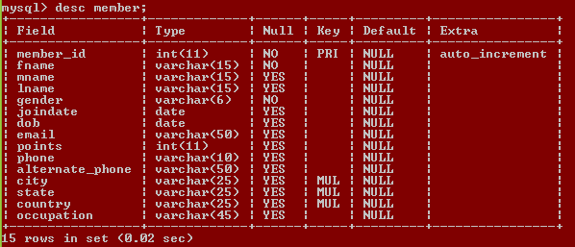

1. **area:**

mysql> show create table area;

+-------+------------------------------------------------------------------------------------------------------------------------

| Table | Create Table

+-------+------------------------------------------------------------------------------------------------------------------------

| area | CREATE TABLE `area` (

`area_id` int(11) NOT NULL AUTO_INCREMENT,

`city` varchar(50) NOT NULL,

`state` varchar(50) NOT NULL,

`country` varchar(50) NOT NULL,

`creation_date` date DEFAULT NULL,

`monitor_id` int(11) DEFAULT NULL,

`area_name` varchar(50) NOT NULL,

PRIMARY KEY (`area_id`),

KEY `fk_monitor_area` (`monitor_id`),

KEY `fk_city_ref_idx` (`city`),

KEY `fk_state_ref_idx` (`state`),

KEY `fk_country_ref_idx` (`country`),

CONSTRAINT `fk_monitor_area` FOREIGN KEY (`monitor_id`) REFERENCES `monitor` (`monitor_id`) ON DELETE SET NULL ON UPDATE CASCADE

) ENGINE=InnoDB AUTO_INCREMENT=22 DEFAULT CHARSET=latin1 |

+-------+------------------------------------------------------------------------------------------------------------------------------

1 row in set (0.00 sec)

**Describe area:**

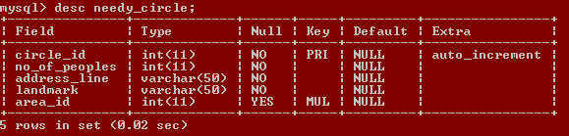

1. **volunteer:**

mysql> show create table volunteer;

+-----------+--------------------------------------------------------------------------------------------------------------------

| Table | Create Table

+-----------+--------------------------------------------------------------------------------------------------------------------

| volunteer | CREATE TABLE `volunteer` (

`member_id` int(11) DEFAULT NULL,

`type` varchar(30) DEFAULT NULL,

`area_id` int(11) DEFAULT NULL,

UNIQUE KEY `Member_Id` (`member_id`),

KEY `fk_member_volunteer` (`member_id`),

KEY `fk_volunteer_area` (`area_id`),

CONSTRAINT `fk_member_volunteer` FOREIGN KEY (`member_id`) REFERENCES `member` (`member_id`) ON DELETE CASCADE ON UPDATE NO ACTION,

CONSTRAINT `fk_volunteer_area` FOREIGN KEY (`area_id`) REFERENCES `area` (`area_id`) ON DELETE CASCADE ON UPDATE NO ACTION

) ENGINE=InnoDB DEFAULT CHARSET=latin1 |

+-----------+--------------------------------------------------------------------------------------------------------------------

**Describe volunteer:**

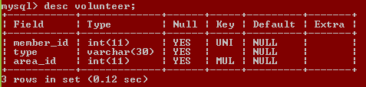

1. **monitor:**

mysql> show create table monitor;

+---------+-----------------------------------------------------------------------------------------------------------

| Table | Create Table

+---------+-----------------------------------------------------------------------------------------------------------| monitor | CREATE TABLE `monitor` (

`monitor_id` int(11) NOT NULL,

`assigned_date` date DEFAULT NULL,

PRIMARY KEY (`monitor_id`),

KEY `fk_monitor` (`monitor_id`),

CONSTRAINT `fk_monitor` FOREIGN KEY (`monitor_id`) REFERENCES `member` (`member_id`) ON DELETE CASCADE ON UPDATE NO ACTION

) ENGINE=InnoDB DEFAULT CHARSET=latin1 |

+---------+-----------------------------------------------------------------------------------------------------------

1 row in set (0.00 sec)

**Describe monitor:**

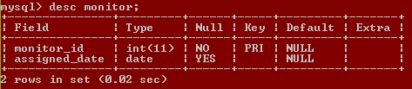

1. **attendance:**

mysql> show create table attendance;

+------------+--------------------------------------------------------------------------------------------------------

| Table | Create Table

+------------+--------------------------------------------------------------------------------------------------------

| attendance | CREATE TABLE `attendance` (

`member_id` int(11) NOT NULL,

`drive_id` int(11) NOT NULL,

`datetime` datetime DEFAULT NULL,

`attendance_flag` int(11) DEFAULT NULL,

`monitor_id` int(11) NOT NULL,

PRIMARY KEY (`member_id`,`drive_id`),

KEY `fk_member_attendance` (`member_id`),

KEY `fk_drive_attendance` (`drive_id`),

KEY `fk_monitor_attendance_idx` (`monitor_id`),

CONSTRAINT `fk_drive_attendance` FOREIGN KEY (`drive_id`) REFERENCES `drive` (`drive_id`) ON DELETE CASCADE ON UPDATE NO ACTION,

CONSTRAINT `fk_member_attendance` FOREIGN KEY (`member_id`) REFERENCES `member` (`member_id`) ON DELETE CASCADE ON UPDATE NO ACTION,

CONSTRAINT `fk_monitor_attendance` FOREIGN KEY (`monitor_id`) REFERENCES `monitor` (`monitor_id`) ON DELETE NO ACTION ON UPDATE NO ACTION

) ENGINE=InnoDB DEFAULT CHARSET=latin1 |

+------------+--------------------------------------------------------------------------------------------------------

1 row in set (0.00 sec)

**Describe attendance:**

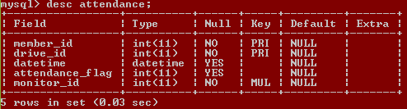

1. **collects_food_from**

mysql> show create table collects_food_from;

+--------------------+------------------------------------------------------------------------------------------------

| Table | Create Table

+--------------------+------------------------------------------------------------------------------------------------

| collects_food_from | CREATE TABLE `collects_food_from` (

`drive_id` int(11) NOT NULL,

`donor_id` int(11) NOT NULL,

`food_quantity` int(11) NOT NULL,

`donation_time` datetime NOT NULL,

`donate_flag` varchar(45) DEFAULT NULL,

`collection_time` datetime DEFAULT NULL,

PRIMARY KEY (`drive_id`,`donor_id`),

KEY `fk_drive_collects` (`drive_id`),

KEY `fk_donor_collects` (`donor_id`),

CONSTRAINT `fk_donor_collects` FOREIGN KEY (`donor_id`) REFERENCES `donor` (`donor_id`) ON DELETE CASCADE ON UPDATE NO ACTION,

CONSTRAINT `fk_drive_collects` FOREIGN KEY (`drive_id`) REFERENCES `drive` (`drive_id`) ON DELETE CASCADE

) ENGINE=InnoDB DEFAULT CHARSET=latin1 |

+--------------------+------------------------------------------------------------------------------------------------

1 row in set (0.00 sec)

**Describe collects_food_from:**

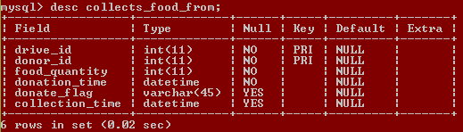

1. **distribute_to:**

mysql> show create table distribute_to;

+---------------+-----------------------------------------------------------------------------------------------------| Table | Create Table

+---------------+-----------------------------------------------------------------------------------------------------

| distribute_to | CREATE TABLE `distribute_to` (

`drive_id` int(11) NOT NULL,

`circle_id` int(11) NOT NULL,

`food_quantity` char(10) NOT NULL,

`decided_time` datetime DEFAULT NULL,

`end_time` datetime DEFAULT NULL,

`distribution_flag` varchar(45) NOT NULL,

PRIMARY KEY (`drive_id`,`circle_id`),

KEY `fk_distribute_to_drive` (`drive_id`),

KEY `fk_distribute_to_circle` (`circle_id`),

CONSTRAINT `fk_distribute_to_circle` FOREIGN KEY (`circle_id`) REFERENCES `needy_circle` (`circle_id`) ON DELETE CASCADE ON UPDATE CASCADE,

CONSTRAINT `fk_distribute_to_drive` FOREIGN KEY (`drive_id`) REFERENCES `drive` (`drive_id`) ON DELETE CASCADE ON UPDATE CASCADE

) ENGINE=InnoDB DEFAULT CHARSET=latin1 |

+---------------+-----------------------------------------------------------------------------------------------------

1 row in set (0.00 sec)

**Describe distribute_to:**

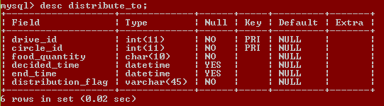

1. **drive:**

mysql> show create table drive;

+-------+-------------------------------------------------------------------------------------------------------------

| Table | Create Table

+-------+-------------------------------------------------------------------------------------------------------------

| drive | CREATE TABLE `drive` (

`drive_id` int(11) NOT NULL AUTO_INCREMENT,

`status` varchar(30) DEFAULT NULL,

`max_volunteers` int(11) DEFAULT NULL,

`start_time` datetime NOT NULL,

`area_id` int(11) NOT NULL,

`monitor_id` int(11) NOT NULL,

`vol_select_method` varchar(45) NOT NULL,

`end_time` datetime DEFAULT NULL,

PRIMARY KEY (`drive_id`),

KEY `fk_area_id_drive_idx` (`area_id`),

KEY `fk_monitor_id_monitor_idx` (`monitor_id`),

CONSTRAINT `fk_area_id_drive` FOREIGN KEY (`area_id`) REFERENCES `area` (`area_id`) ON DELETE CASCADE ON UPDATE NO ACTION,

CONSTRAINT `fk_monitor_id_monitor` FOREIGN KEY (`monitor_id`) REFERENCES `monitor` (`monitor_id`) ON DELETE CASCADE ON UPDATE NO ACTION

) ENGINE=InnoDB AUTO_INCREMENT=19 DEFAULT CHARSET=latin1 |

+-------+-------------------------------------------------------------------------------------------------------------

1 row in set (0.00 sec)

**Describe drive:**

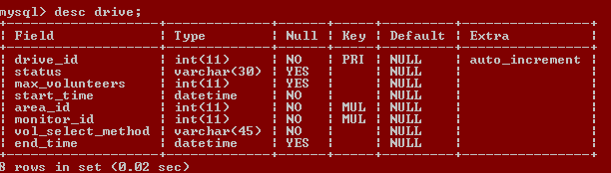

1. **donor:**

mysql> show create table donor;

+-------+-------------------------------------------------------------------------------------------------------------

| Table | Create Table

+-------+-------------------------------------------------------------------------------------------------------------

| donor | CREATE TABLE `donor` (

`donor_id` int(11) NOT NULL AUTO_INCREMENT,

`donor_name` varchar(25) NOT NULL,

`email` varchar(50) DEFAULT NULL,

`address_line` varchar(50) NOT NULL,

`city` varchar(50) NOT NULL,

`state` varchar(50) NOT NULL,

`country` varchar(50) NOT NULL,

`type` varchar(10) NOT NULL,

`phone` varchar(10) NOT NULL,

`alternate_phone` varchar(10) DEFAULT NULL,

`area_id` int(11) DEFAULT NULL,

`points` int(11) NOT NULL DEFAULT '0',

PRIMARY KEY (`donor_id`),

UNIQUE KEY `email_UNIQUE` (`email`),

KEY `fk_area_id_donor_idx` (`area_id`),

CONSTRAINT `fk_area_id_donor` FOREIGN KEY (`area_id`) REFERENCES `area` (`area_id`) ON DELETE CASCADE ON UPDATE NO ACTION

) ENGINE=InnoDB AUTO_INCREMENT=15 DEFAULT CHARSET=latin1 |

+-------+-------------------------------------------------------------------------------------------------------------

1 row in set (0.00 sec)

**Describe donor:**

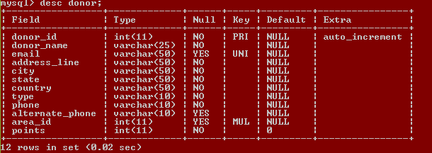

1. **needy_circle:**

mysql> show create table needy_circle;

+--------------+------------------------------------------------------------------------------------------------------

| Table  | Create Table

+--------------+------------------------------------------------------------------------------------------------------

| needy_circle | CREATE TABLE `needy_circle` (

`circle_id` int(11) NOT NULL AUTO_INCREMENT,

`no_of_peoples` int(11) NOT NULL,

`address_line` varchar(50) NOT NULL,

`landmark` varchar(50) NOT NULL,

`area_id` int(11) DEFAULT NULL,

PRIMARY KEY (`circle_id`),

KEY `fk_needy_circle_area` (`area_id`),

CONSTRAINT `fk_needy_circle_area` FOREIGN KEY (`area_id`) REFERENCES `area` (`area_id`) ON DELETE CASCADE ON UPDATE NO ACTION

) ENGINE=InnoDB AUTO_INCREMENT=6 DEFAULT CHARSET=latin1 |

+--------------+------------------------------------------------------------------------------------------------------

1 row in set (0.00 sec)

**Describe needy_circle:**

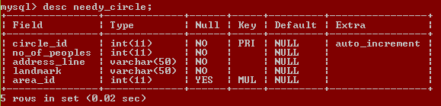

1. **request_for_join:**

mysql> show create table team_join_req;

+---------------+-----------------------------------------------------------------------------------------------------

| Table | Create Table

+---------------+-----------------------------------------------------------------------------------------------------

| team_join_req | CREATE TABLE `team_join_req` (

`req_id` int(11) NOT NULL AUTO_INCREMENT,

`reference_id` int(11) DEFAULT NULL,

`area_id` int(11) DEFAULT NULL,

`status_flag` int(11) DEFAULT NULL,

`role` varchar(20) DEFAULT NULL,

PRIMARY KEY (`req_id`),

KEY `fk_area_ref_join_idx` (`area_id`),

CONSTRAINT `fk_area_ref_join` FOREIGN KEY (`area_id`) REFERENCES `area` (`area_id`) ON DELETE CASCADE ON UPDATE NO ACTION

) ENGINE=InnoDB AUTO_INCREMENT=46 DEFAULT CHARSET=latin1 |

+---------------+-----------------------------------------------------------------------------------------------------

1 row in set (0.00 sec)

**Describe request_for_join:**

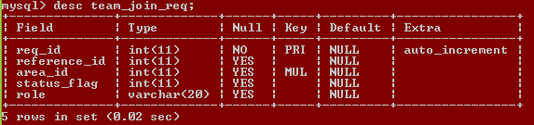

**ILLUSTRATION OF QUERYING THE SYSTEM USING MYSQL**

In this section, various instances of querying the system using MYSQL will be shown. The results are also shown.

**WHERE** clause usage:

To select area_name of area_id=1;

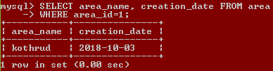

To select donor names in area_id=1:

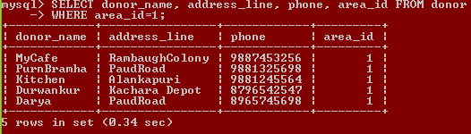

To select all needy circles from area_id=1:

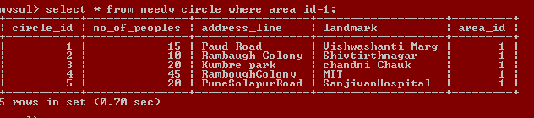

**ORDER BY and LIKE** clause usage:

To search drive information from any column of drive :

SELECT *

FROM drive

WHERE CONCAT_WS(',',drive_id,status,max_volunteers,start_time,end_time,monitor_id,area_id,vol_select_method)

LIKE '%FC%'

AND area_id=1 AND status<>'Completed' ORDER BY status DESC,start_time;

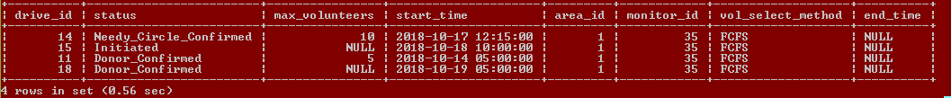

**JOIN** clause usage:

To get ALL information about monitor:

SELECT member.fname,

member.lname,

member.gender,

member.dob,

member.email,

member.points,

member.phone,

monitor.monitor_id,

monitor.assigned_date,

area.area_id,

area.area_name

FROM ((member

INNER JOIN monitor

ON monitor.monitor_id=member.member_id)

INNER JOIN area

ON area.monitor_id=monitor.monitor_id)

WHERE monitor.monitor_id=35



**DISTINCT clause usage:**

To select all distinct address lines from needy_circle of area_id=1:

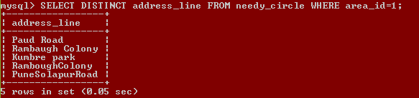

To select all distinct landmarks from needy_circle of area_id=1:

